Leave Management Portal (PHP + MVC + MySQL + AJAX)
Scenario: Create a “Leave Management System” for employees in a company.

Functional Requirements:
- Employee Login/Register (basic auth).
- Apply for leave by selecting date range, reason, and leave type.
- View leave application status and leave history.
- Admin login to:
  - Approve/Reject leave requests.
  - View total leaves taken by each employee.
- Use AJAX to show real-time leave balance and overlapping dates check.
- Use PHP sessions for authentication and MVC pattern for code separation.
- Must apply logical conditions like:
  - Max 2 casual leaves/month.
  - Cannot apply leave on already approved dates.

CREATE A FOLDER NAMED leave-management INSIDE xampp/htdocs:
Place the project files inside the billing folder.
PROJECT STRUCTURE:
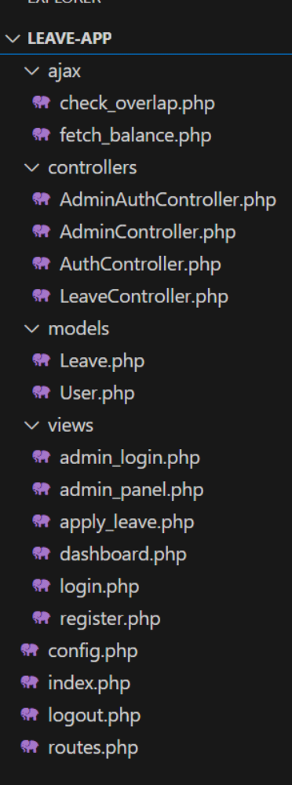

- Database:
xammp mysql
CREATE DATABASE leave_management;
USE leave_management;

CREATE TABLE users (
id INT AUTO_INCREMENT PRIMARY KEY,
name VARCHAR(100),
email VARCHAR(100) UNIQUE,
password VARCHAR(255),
role ENUM('employee', 'admin') DEFAULT 'employee'
);

CREATE TABLE leaves (
id INT AUTO_INCREMENT PRIMARY KEY,
user_id INT,
leave_type VARCHAR(50),
start_date DATE,
end_date DATE,
reason TEXT,
status ENUM('Pending', 'Approved', 'Rejected') DEFAULT 'Pending',
created_at TIMESTAMP DEFAULT CURRENT_TIMESTAMP,
FOREIGN KEY (user_id) REFERENCES users(id)
);
CREATE TABLE admins (
id INT AUTO_INCREMENT PRIMARY KEY,
name VARCHAR(100),
email VARCHAR(100) UNIQUE,
password VARCHAR(255)
);
- ajax/check_overlap.php:

<?php
require '../config.php';

$userId = $_SESSION['user']['id'];
$start = $_GET['start_date'];
$end = $_GET['end_date'];

$sql = "SELECT * FROM leaves
WHERE user_id = $userId
AND status = 'Approved'
AND (
(start_date <= '$end' AND end_date >= '$start')
)";

$result = $conn->query($sql);

if ($result->num_rows > 0) {
echo "overlap"; // Used by JS to prevent submission
} else {
echo "ok";
}

ajax/fetch_balance.php:
<?php
require '../config.php';

$type = $_GET['type'];
$userId = $_SESSION['user']['id'];

if ($type === 'Casual') {
$month = date('m');
$year = date('Y');
$res = $conn->query("SELECT COUNT(*) as cnt FROM leaves WHERE user_id=$userId AND leave_type='Casual' AND MONTH(start_date)=$month AND YEAR(start_date)=$year");
echo "Casual leaves used this month: " . $res->fetch_assoc()['cnt'];
} else {
echo "Unlimited";
}

controllers/AdminAuthController.php:
<?php
require '../config.php';

$action = $_GET['action'];

if ($action === 'login') {
$email = $_POST['email'];
$pass = $_POST['password'];

$stmt = $conn->prepare("SELECT * FROM admins WHERE email = ?");
$stmt->bind_param("s", $email);
$stmt->execute();
$admin = $stmt->get_result()->fetch_assoc();

if ($admin && $pass === $admin['password']) {
$_SESSION['admin'] = $admin;
header("Location: ../views/admin_panel.php");
} else {
echo "Login failed";
}
}

controller/AdminController.php:
<?php
require '../config.php';
require '../models/Leave.php';

$action = $_GET['action'];
$id = $_GET['id'];

if ($action === 'approve') {
Leave::updateStatus($id, 'Approved', $conn);
header("Location: ../views/admin_panel.php");
} elseif ($action === 'reject') {
Leave::updateStatus($id, 'Rejected', $conn);
header("Location: ../views/admin_panel.php");
}

Controller/AuthController.php:
<?php
require '../config.php';
require '../models/User.php';

$action = $_GET['action'];

if ($action === 'login') {
$user = User::find($_POST['email'], $conn);

if ($user && password_verify($_POST['password'], $user['password'])) {
// Store user info in session
$_SESSION['user'] = $user;

// Redirect based on user role
if ($user['role'] === 'admin') {
header('Location: ../views/admin_panel.php');
} else {
header('Location: ../views/dashboard.php');
}
exit(); // Make sure to stop further execution after redirect
} else {
echo "Login failed. Invalid credentials.";
}
}

if ($action === 'register') {
User::create($_POST['name'], $_POST['email'], $_POST['password'], $conn);
header("Location: ../index.php?page=login");
exit(); // Ensure the script doesn't continue after redirect
}

Controller/LeaveController.php:
<?php
require '../config.php';
require '../models/Leave.php';

$userId = $_SESSION['user']['id'];
$type = $_POST['leave_type'];
$start = $_POST['start_date'];
$end = $_POST['end_date'];
$reason = $_POST['reason'];

// Max 2 casual leaves/month
if ($type === 'Casual') {
$month = date('m', strtotime($start));
$year = date('Y', strtotime($start));
$res = $conn->query("SELECT COUNT(*) AS total FROM leaves WHERE user_id=$userId AND leave_type='Casual' AND MONTH(start_date)=$month AND YEAR(start_date)=$year");
$count = $res->fetch_assoc()['total'];
if ($count >= 2) {
die("Only 2 Casual Leaves allowed per month");
}
}

// Check for overlapping dates
$res = $conn->query("SELECT * FROM leaves WHERE user_id=$userId AND status='Approved' AND (
(start_date <= '$end' AND end_date >= '$start')
)");
if ($res->num_rows > 0) {
die("Leave overlaps with already approved leave");
}

Leave::apply($userId, $type, $start, $end, $reason, $conn);
header("Location: ../index.php?page=dashboard");

Models/Leave.php:
<?php
class Leave {
public static function apply($userId, $type, $start, $end, $reason, $conn) {
$stmt = $conn->prepare("INSERT INTO leaves (user_id, leave_type, start_date, end_date, reason) VALUES (?, ?, ?, ?, ?)");
$stmt->bind_param("issss", $userId, $type, $start, $end, $reason);
return $stmt->execute();
}

public static function getByUser($userId, $conn) {
$stmt = $conn->prepare("SELECT * FROM leaves WHERE user_id = ?");
$stmt->bind_param("i", $userId);
$stmt->execute();
return $stmt->get_result();
}

public static function getAll($conn) {
return $conn->query("SELECT l.*, u.name FROM leaves l JOIN users u ON l.user_id = u.id");
}

public static function updateStatus($id, $status, $conn) {
$stmt = $conn->prepare("UPDATE leaves SET status = ? WHERE id = ?");
$stmt->bind_param("si", $status, $id);
return $stmt->execute();
}
}

Models/User.php:
<?php
class User {
public static function find($email, $conn) {
$stmt = $conn->prepare("SELECT * FROM users WHERE email = ?");
$stmt->bind_param("s", $email);
$stmt->execute();
return $stmt->get_result()->fetch_assoc();
}

public static function create($name, $email, $pass, $conn) {
$hash = password_hash($pass, PASSWORD_DEFAULT);
$stmt = $conn->prepare("INSERT INTO users (name, email, password) VALUES (?, ?, ?)");
$stmt->bind_param("sss", $name, $email, $hash);
return $stmt->execute();
}
}

Views/admin_login.php:
<form action="../controllers/AdminAuthController.php?action=login" method="POST">
<h2>Admin Login</h2>
<input name="email" placeholder="Email" required>
<input name="password" type="password" placeholder="Password" required>
<button type="submit">Login</button>
</form>

Views/admin_panel.php:
<?php
require '../config.php';
require '../models/Leave.php';

if (!isset($_SESSION['admin'])) {
header("Location: admin_login.php");
exit;
}
?>

<h2>Welcome, <?= $_SESSION['admin']['name'] ?> (Admin)</h2>
<a href="logout.php">Logout</a>

<h3>Leave Requests</h3>
<?php
$requests = Leave::getAll($conn);
while ($row = $requests->fetch_assoc()) {
echo "{$row['name']} - {$row['start_date']} to {$row['end_date']} - {$row['status']}
<a href='../controllers/AdminController.php?action=approve&id={$row['id']}'>Approve</a> |
<a href='../controllers/AdminController.php?action=reject&id={$row['id']}'>Reject</a><br>";
}
?>

Views/apply_leave.php:
<form action="controllers/LeaveController.php" method="POST">
<select name="leave_type">
<option value="Casual">Casual</option>
<option value="Sick">Sick</option>
</select>
<input name="start_date" type="date" required>
<input name="end_date" type="date" required>
<textarea name="reason" placeholder="Reason"></textarea>
<button type="submit">Apply</button>
</form>
<div id="leaveBalance"></div>
<script>
document.querySelector('select[name="leave_type"]').onchange = function() {
fetch(`ajax/fetch_balance.php?type=${this.value}`)
.then(res => res.text())
.then(data => document.getElementById('leaveBalance').innerText = data);
};
</script>

Views/dashboard.php:
<?php
if (session_status() == PHP_SESSION_NONE) {
session_start();
}
require_once(__DIR__ . '/../config.php');

// Ensure the logged-in user is an employee
if ($_SESSION['user']['role'] !== 'employee') {
header("Location: ../views/admin_panel.php"); // Redirect to the admin panel if not employee
exit();
}

?>
<h2>Welcome <?= $_SESSION['user']['name'] ?></h2>
<a href="../index.php?page=apply_leave">Apply Leave</a>
<a href="../logout.php">Logout</a>

<h3>Your Leave History</h3>
<?php
require_once(__DIR__ . '/../models/Leave.php');

$leaves = Leave::getByUser($_SESSION['user']['id'], $conn);
while ($leave = $leaves->fetch_assoc()) {
echo "{$leave['start_date']} to {$leave['end_date']} - {$leave['leave_type']} - {$leave['status']}<br>";
}
?>

Views/login.php:

<form action="controllers/AuthController.php?action=login" method="POST">
<h2>Login</h2>
<input name="email" placeholder="Email" required>
<input name="password" type="password" placeholder="Password" required>
<button type="submit">Login</button>
<a href="index.php?page=register">Register</a>
</form>

Views/register.php:
<form action="controllers/AuthController.php?action=register" method="POST">
<h2>Register</h2>
<input name="name" placeholder="Name" required>
<input name="email" placeholder="Email" required>
<input name="password" type="password" placeholder="Password" required>
<button type="submit">Register</button>
</form>

Config.php:
<?php
if (session_status() === PHP_SESSION_NONE) {
session_start();
}

$host = 'localhost';
$db = 'leave_management';
$user = 'root';
$pass = '';

$conn = new mysqli($host, $user, $pass, $db);
if ($conn->connect_error) {
die("Connection failed: " . $conn->connect_error);
}
?>

Index.php:
<?php
require 'config.php';
require 'routes.php';

Logout.php:
<?php
session_start();
session_destroy();
header("Location: index.php?page=login");

Routes.php:
<?php
$path = $_GET['page'] ?? 'login';

switch ($path) {
case 'login': include 'views/login.php'; break;
case 'register': include 'views/register.php'; break;
case 'dashboard': include 'views/dashboard.php'; break;
case 'apply_leave': include 'views/apply_leave.php'; break;
case 'admin': include 'views/admin_panel.php'; break;
default: include 'views/login.php';
}

Output:
employee register page
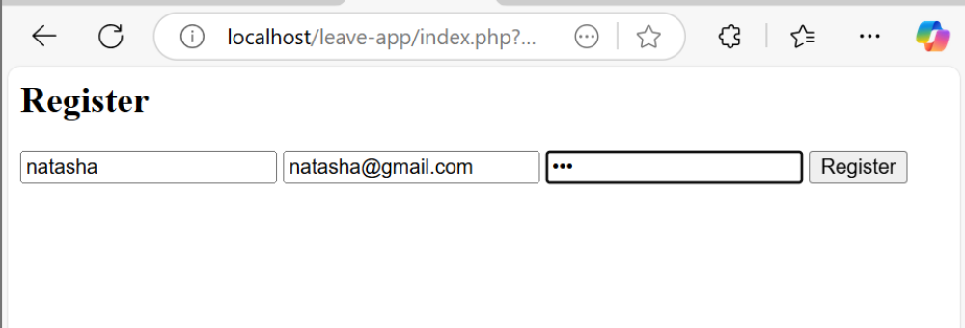

employee login page:
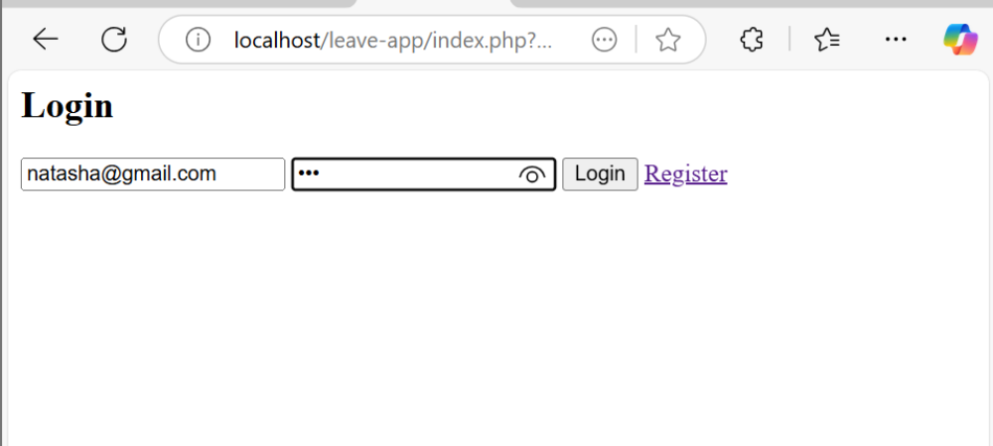
leave application page
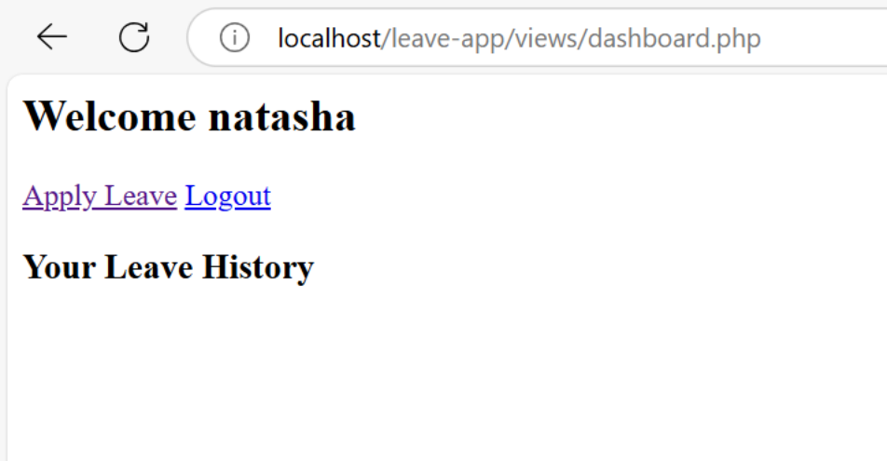
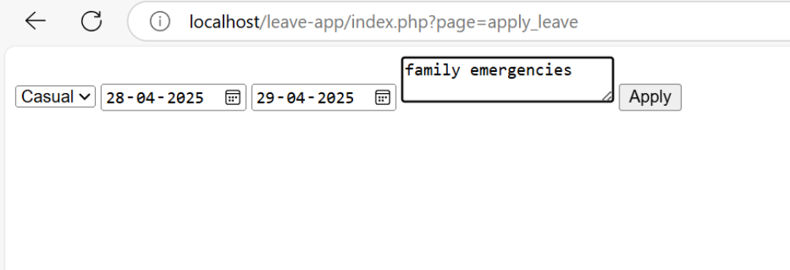
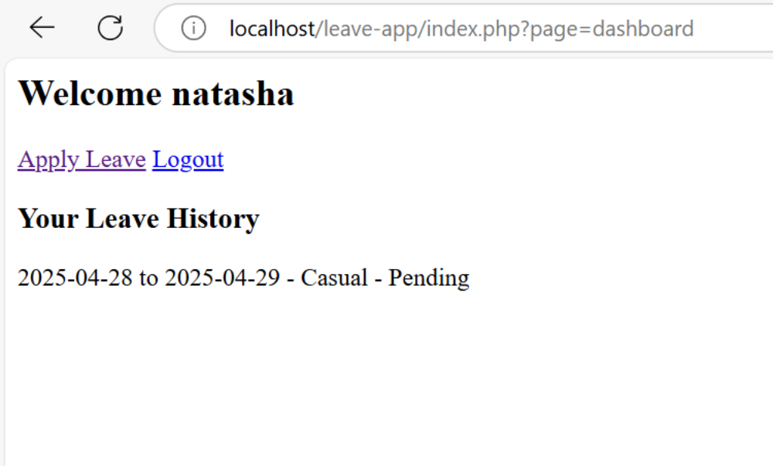
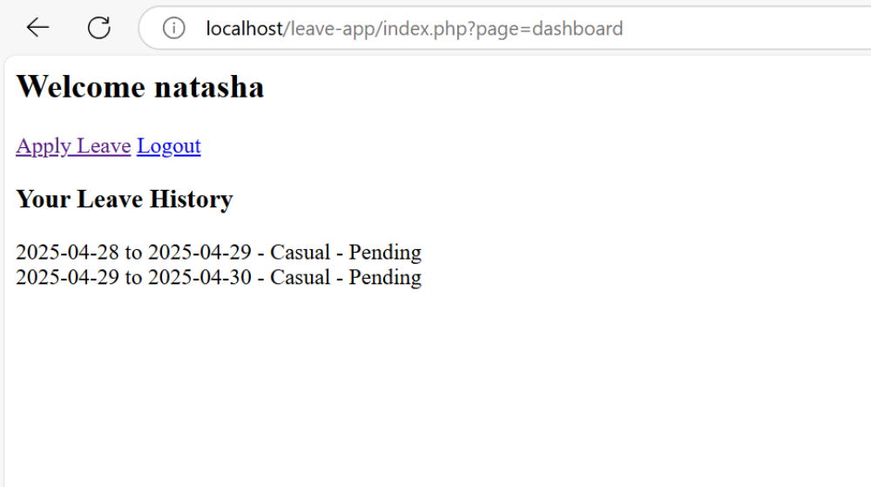

maximum 2 casual leave per month
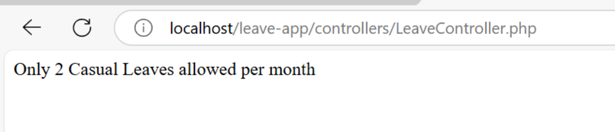

admin page to approve or reject leave application

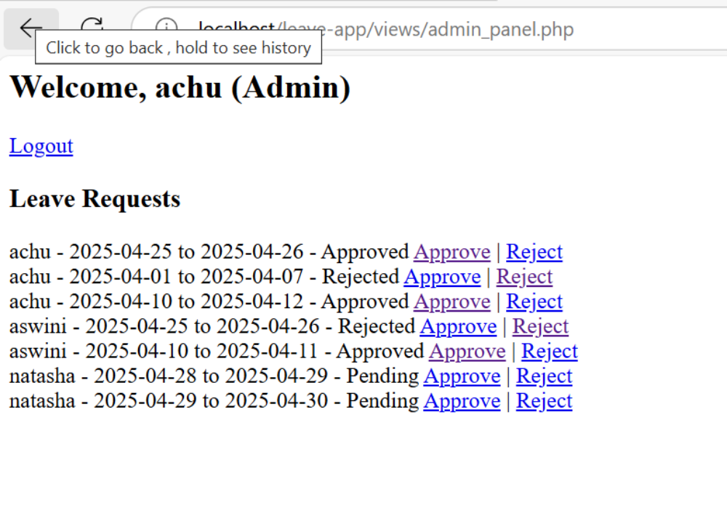

approval and rejection status change in the employee leave history
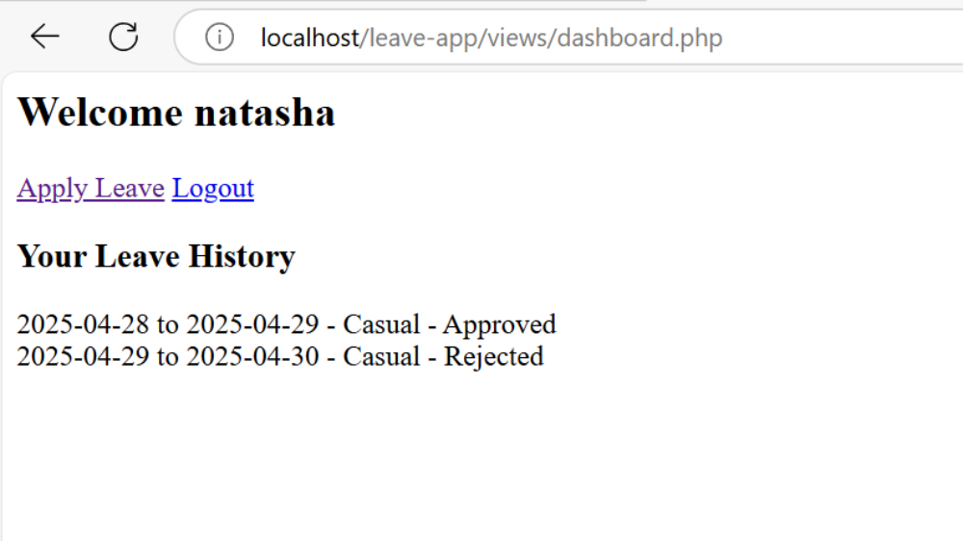

folder structure:

